**P7- Implement a control system**

**Introduction**

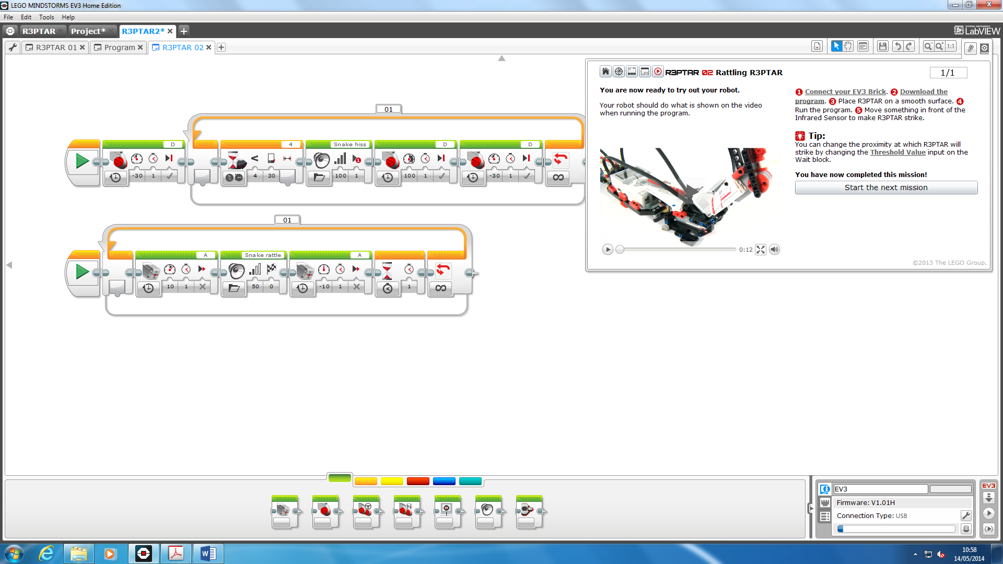

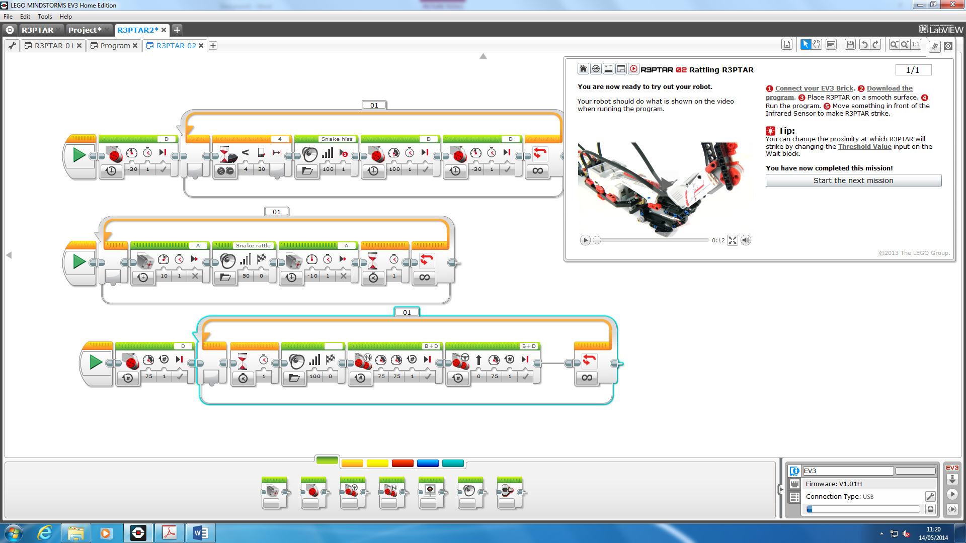

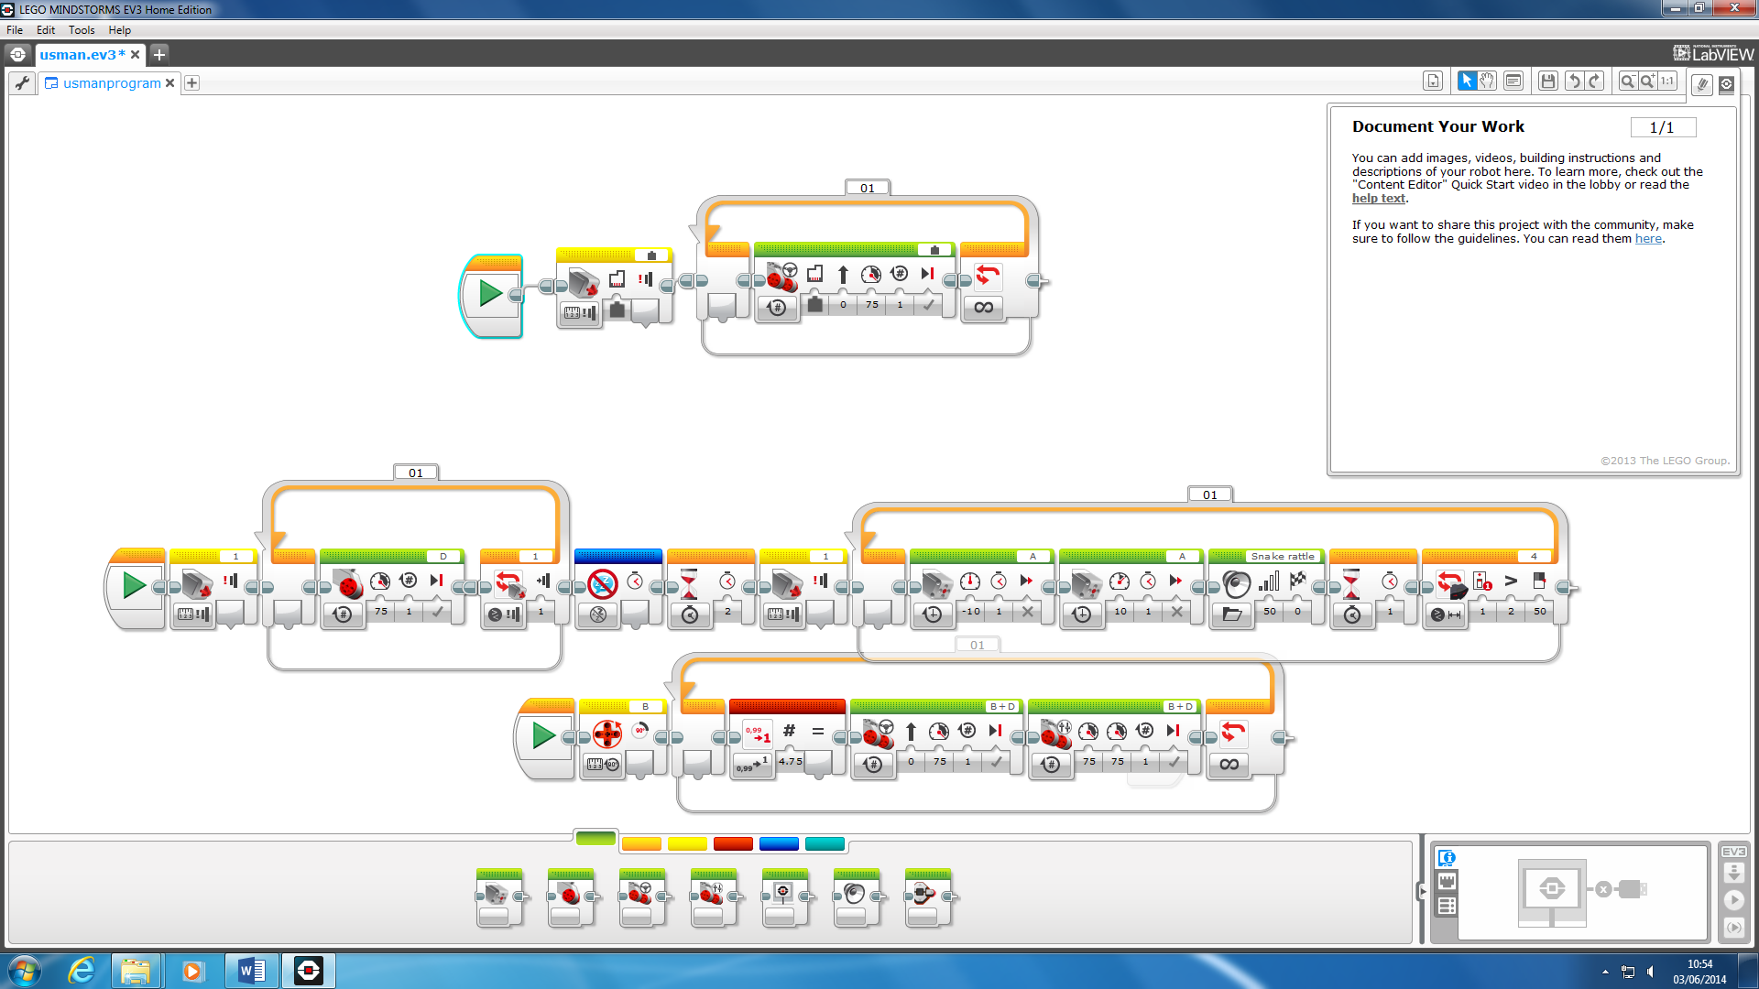

|  |  |  |  |  |
| --- | --- | --- | --- | --- |
| **Test number** | **Description** | **Input data/values** | **Expected outcome** | **Actual outcome** |
|  |  |  |  |  |
|  |  |  |  |  |
|  |  |  |  |  |
|  |  |  |  |  |
|  |  |  |  |  |
|  |  |  |  |  |
|  |  |  |  |  |
|  |  |  |  |  |
|  |  |  |  |  |
|  |  |  |  |  |

**TEST PLAN**